Normalized Relational Schema

LAB # 08



Spring 2024
CSE-403L Database Management Systems Lab

Submitted by:
Ali Asghar (21PWCSE2059)
Shahzad Bangash (21PWCSE1980)
Suleman Shah (21PWCSE1983)

Class Section: C

Submitted to:
Engr. Sumayyea Salahuddin

Date:
5th June 2024

Department of Computer Systems Engineering
University of Engineering and Technology, Peshawar

Objectives:
This lab aims at the understanding of:
- Normalized Relational Schema
- Relational Schema
- 3NF Normalized Relations

Task 8.1:
Submit the Complete Relational/Logical Schema of your DBMS Project including:
1. Relational Schema: Transformation of ERD and EERD into Relations
2. Normalization: 3NF of Relational Schema

Converted Relational Schema:
First Normal Form (1NF)
The current structure is in 1NF as all attributes contain atomic values.

Second Normal Form (2NF)
All tables satisfy 2NF as all non-key attributes depend on the entire primary key.

Third Normal Form (3NF)
The hall_id in Manager Table should not be in the Manager table as it creates a transitive dependency (hall_id depends on manager_id, and attributes in the Hall table depend on hall_id). Instead, we create a separate Manages table.
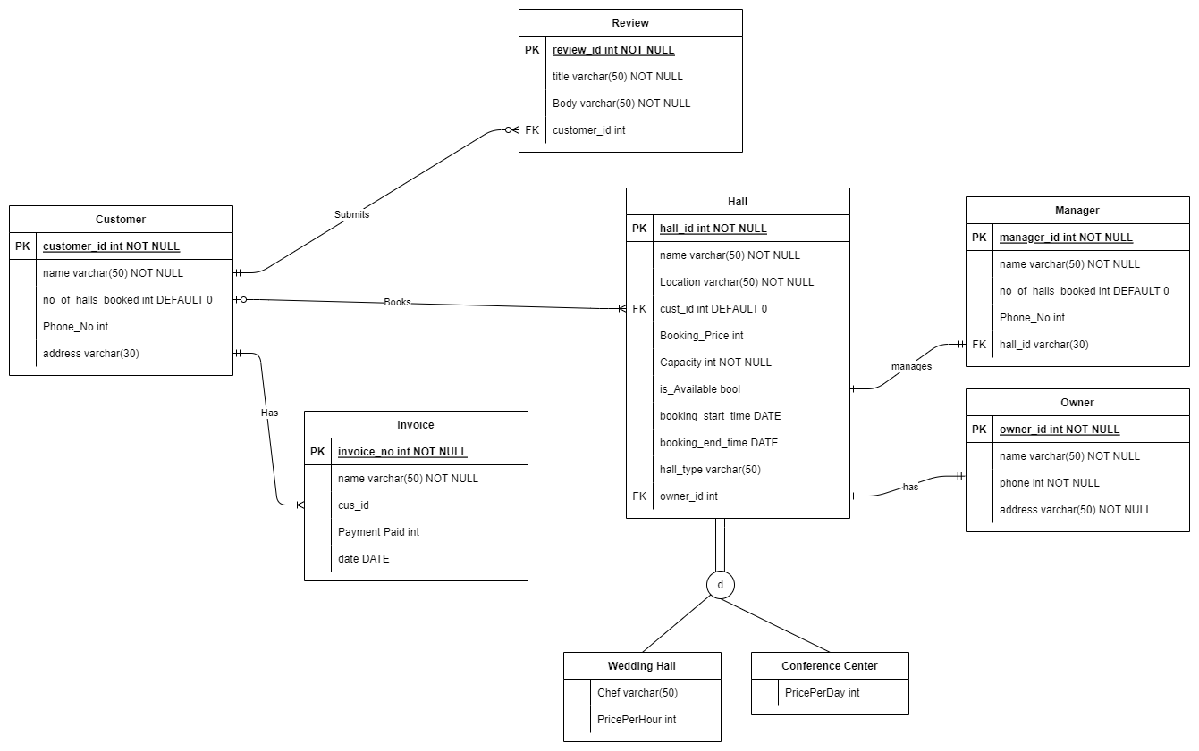
Figure 1-1, Unnormalized Relational Schema of Hall Booking System

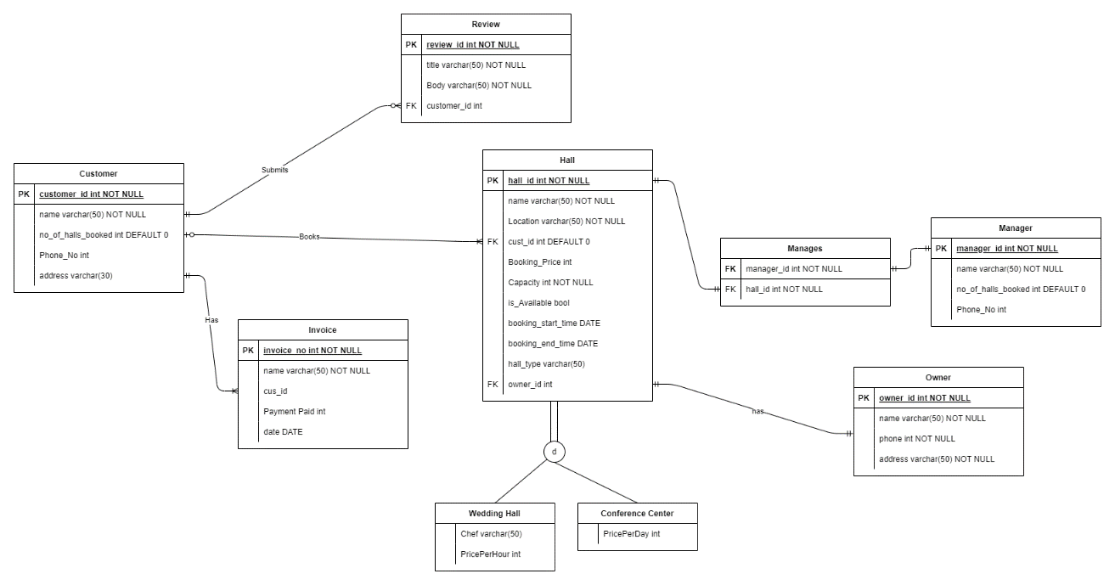
Normalized Relational Schema:
Figure 1-2, Normalized Relational Schema of Hall Booking System

